**Assignment: 9**

**Probblem Statement:** Deploy a project from Github to EC2

**Procedure:**

1. Login to the AWS and create an EC2 instance Click on EC2 **->** Go to instances **->** Click “Launch Instances” (Create the instance. Provide the name of the instance, set the OS as UBUNTU), **->** “Create new key pair” Key pair (click “create new key pair” provide the key pair name set as .pem), Select all the security policy **->** click launch instance. Again back to the instances **->** Click on the instance ID

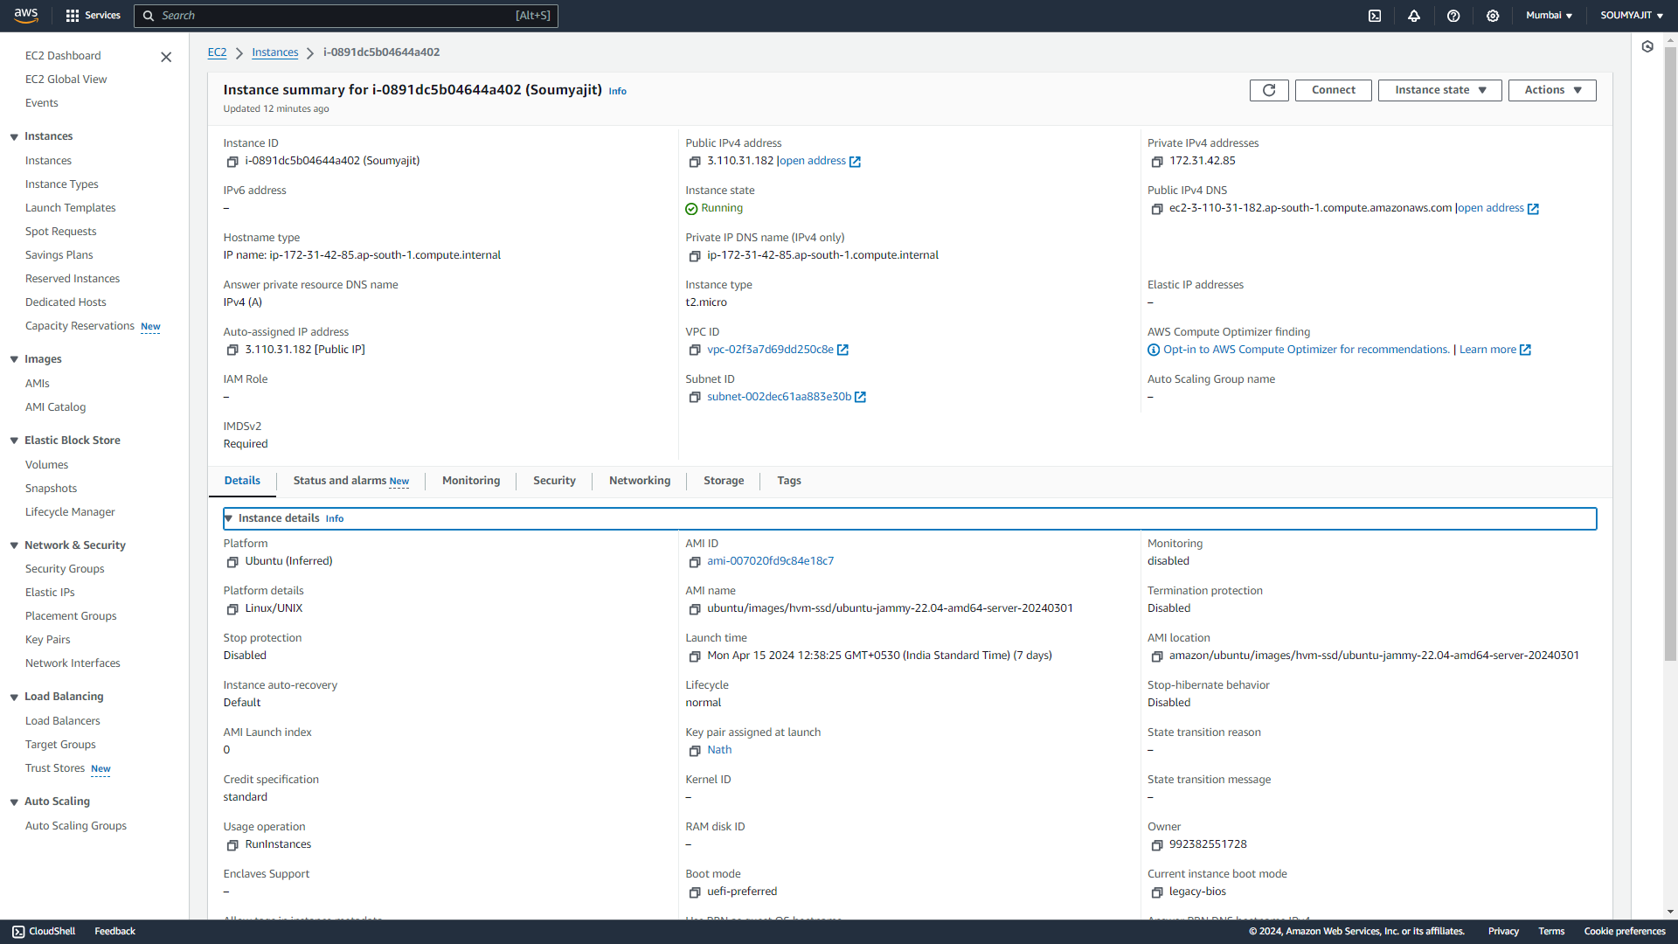

1. Open Bitvise SSH Client Application and Paste the public IPv4 of the instance.
2. Give Username as ubuntu.
3. Client Key Manager, remove existing Keys and import the new key.
4. Login in user authentication.



1. Open New terminal console Enter and execute the following Command

* Pwd
* sudo apt-get update
* sudo apt-get upgrade
* sudo apt-get install nginx
* curl -SL https://deb.nodesource.com/setup_18.x | sudo -E bash
* sudo apt install nodejs
* node -v
* git clone https://github.com/moumita02314/myawsproject1

1. Enter in the directry “myawsproject1” and execute the following commands

* dir
* npm install
* node index.js

after run all the commands it will show that the “started server”

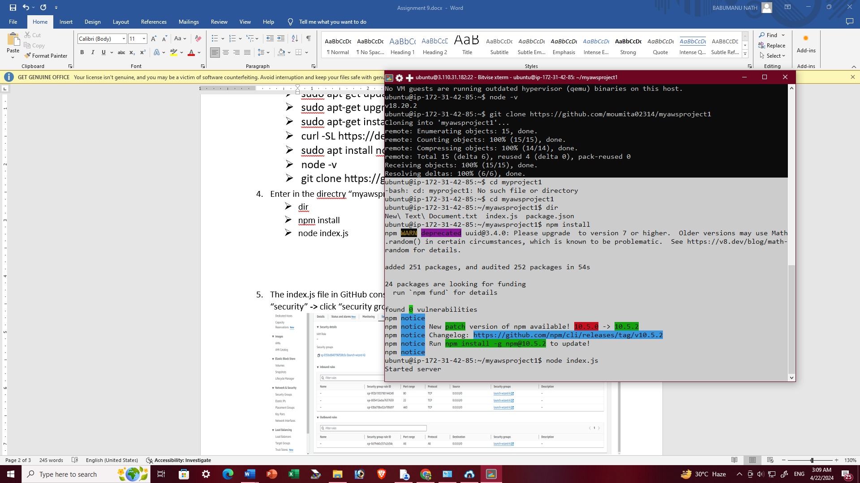

1. The index.js file in GitHub consists of port no “4000”. Go to the instance ID click on the “security” **->** click “security groups” ID

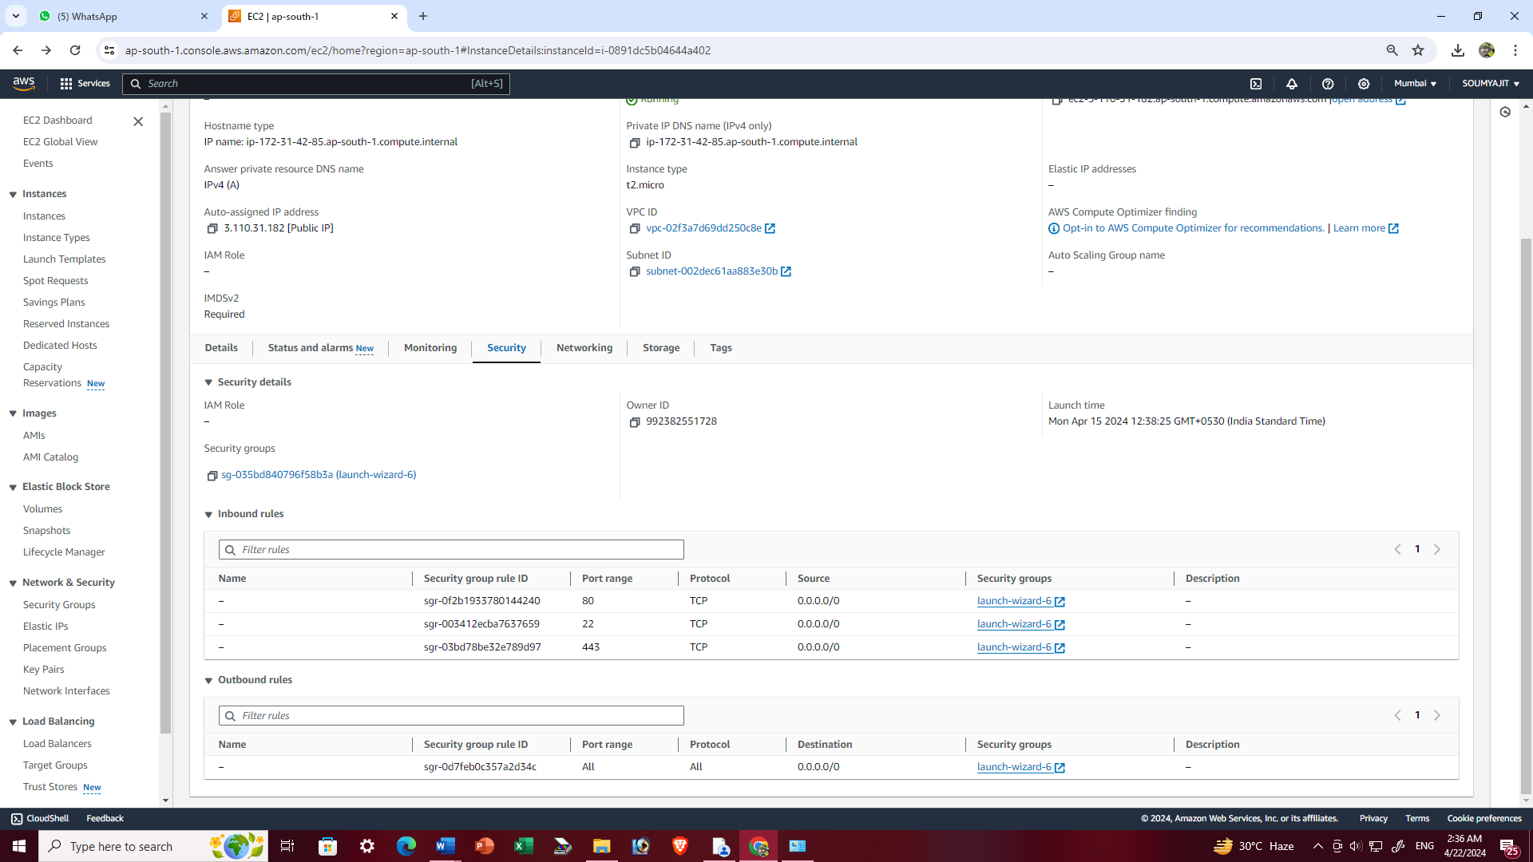

1. Click “Edit inbound rules”

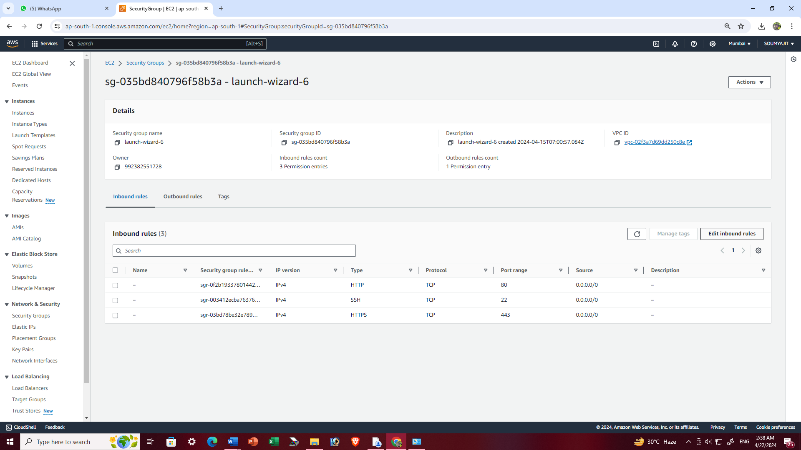

1. Click on Add rules --> set Type as ‘Custom TCP’ with Port range of ‘4000’ , Source as ‘Anywhere-IPv4’ and Save the rule

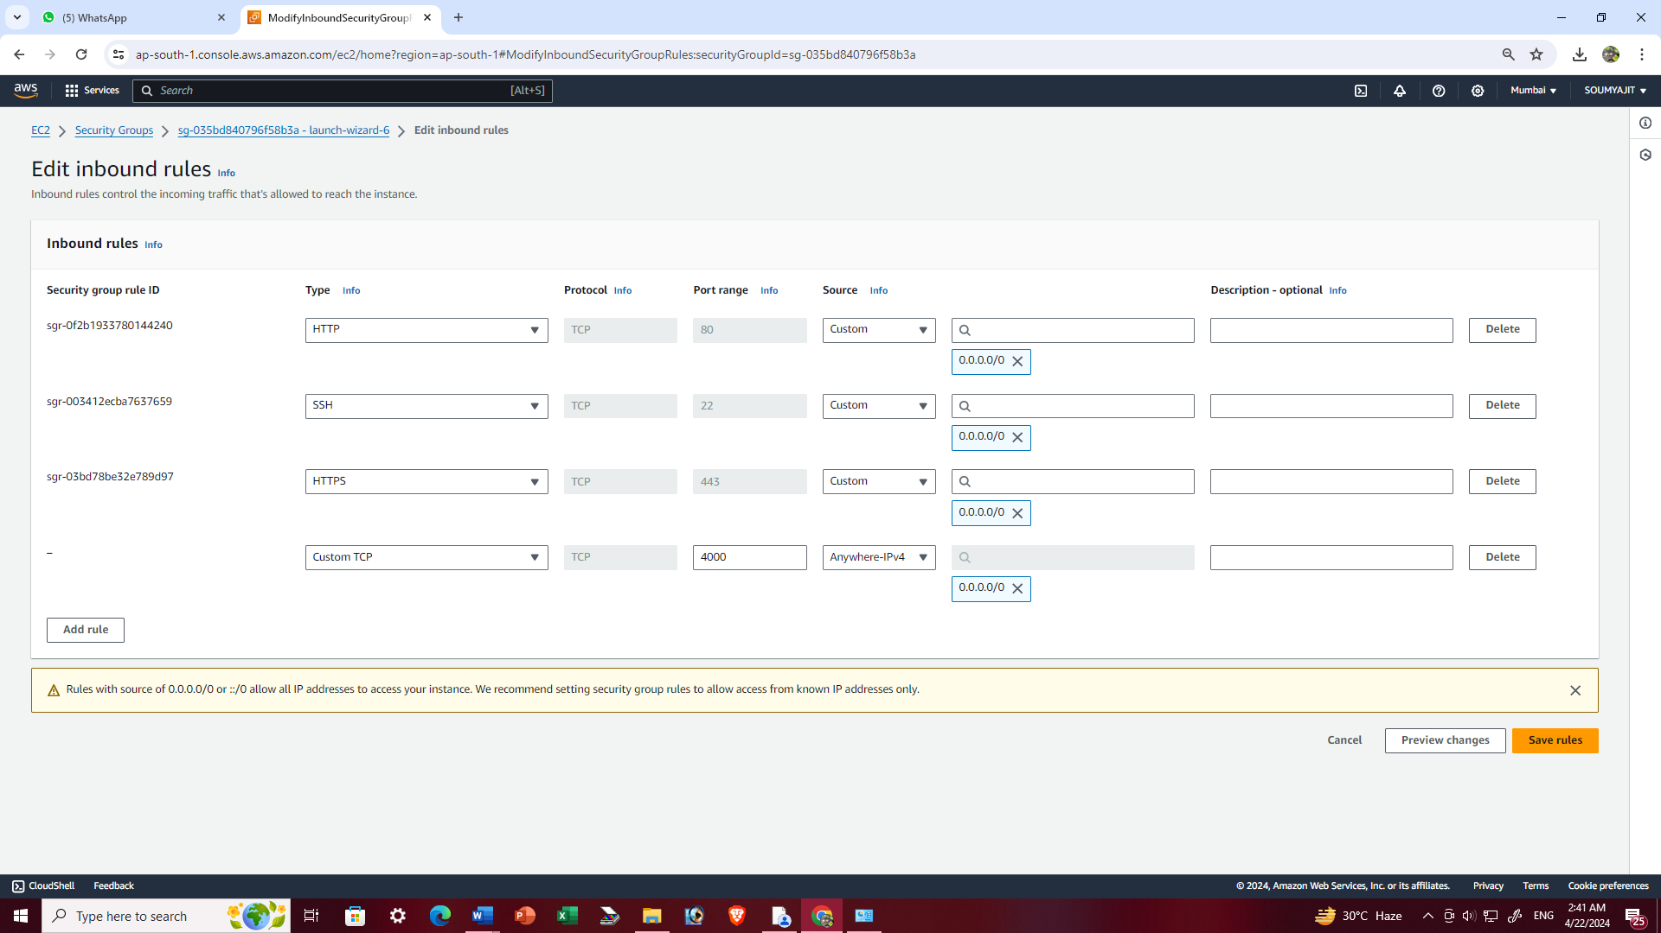

Rule is save successfully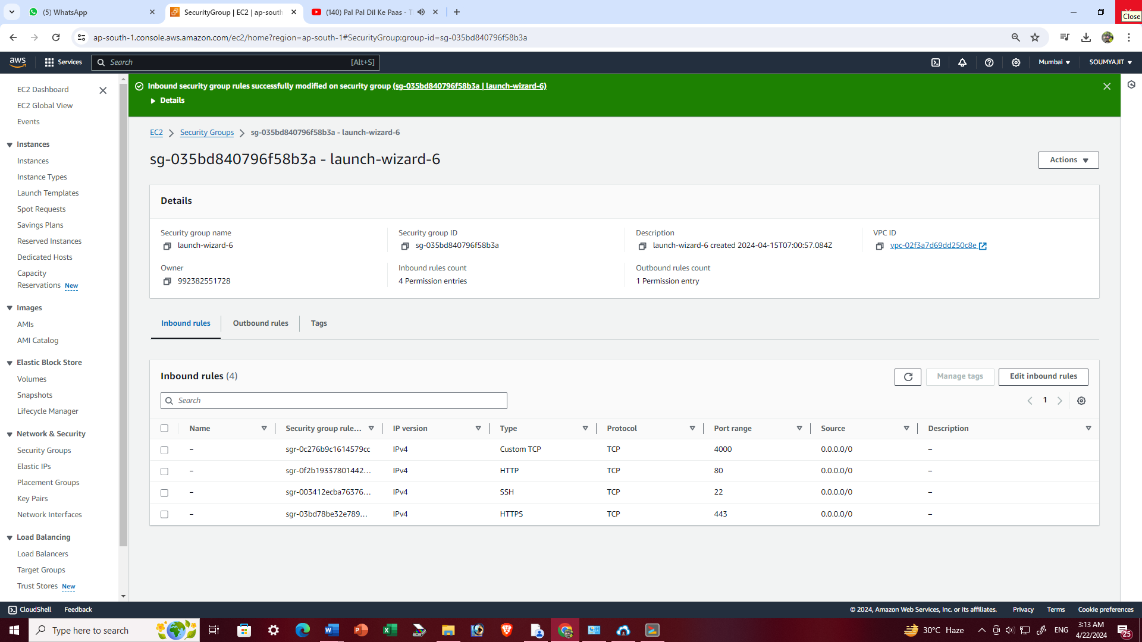

1. Go to web browser and give the port number (4000) after the public IPv4. Press Enter.



Server is activate